

217, Sheikh Rashid Building

P.O Box 56272, Dubai

United Arab Emirates

Tel: +971 4 2973236 / 04 2974007

Email: uae@verbat.com

Feasibility   
Study

**Livestock Tracking System**

|  |  |
| --- | --- |
| **Prepared for:** |  |

___________________________________________________________________________________________________________________________________________  
Conﬁdentiality Notice: This document is conﬁdential and contains proprietary information and intellectual property of Verbanet Technologies LLC. Neither this document nor any of the information contained herein may be reproduced or disclosed under any circumstances without the express written permission of Verbanet.

© 2017 by Verbanet Technologies LLC. All rights reserved. Confidential.

___________________________________________________________________________________________________________________________________________

Project Contacts

|  |  |
| --- | --- |
| Client Information | |
| Project Name | Feasibility study for livestock tracking system |
| Client Name |  |
| Client Address |  |
| Contact Person |  |
| Contact Person Email |  |
| Contact Person Phone Number |  |
| Verbat Information | |
| Contact Person | Shibu Kumar |
| Contact Person Phone Number | +91 471 6003295 |
| Contact Person E-Mail | [shibu.kumar@verbat.com](mailto:shibu.kumar@verbat.com) |
| Address | Level 3, PTC Tower, Nanthancode Trivandrum, Kerala |

**Table of Content**

1 Executive Summary 3

1.1 Description of products and services 4

1.2 Technology consideration 5

1.2.1 Concept 6

# Executive Summary

A microchip implant is an identifying integrated circuit placed under the skin of an animal. The chip, about the size of a large grain of rice, uses passive RFID (Radio Frequency Identification) technology, and is also known as a PIT tag (for Passive Integrated Transponder).

The Animal Health Department (AHD) Team would like to monitor and retrieve the data on microchips embedded in the animal skin. The primary data to be retrieved is an identification number. This information should be propagated to an existing application. Current devices used to read the RFID data are bulky and expensive (~ INR 5000/-). AHD Envisions the development of a RFID reader that is far cheaper and commercially viable than the alternatives available in the market.

## Description of products and services

Low Frequency (LF) RFID is a band on the radio frequency spectrum that typically operates between 125 kHz and 134 kHz. Technically, LF applications can operate on a larger bandwidth from 30 kHz to 300 kHz; however, the specific band varies from country to country and depends on frequencies set aside for radio and marine life tracking.

The potential applications for these devices extend from tracking animal population to storing biometric information about the animal in the RFID chips. Some examples are cites below:

Animal shelters, animal control officers and veterinarians routinely look for microchips to return lost pets quickly to their owners, avoiding expenses for housing, food, medical care, outplacing and euthanasia. Many shelters place chips in all outplaced animals.

Microchips are also used by kennels, breeders, brokers, trainers, registries, rescue groups, humane societies, clinics, farms, stables, animal clubs and associations, researchers, and pet stores.

New equipment and software is available that builds on the LF RFID identification premise, but offer new data and options. These new livestock tracking RFID systems use UHF RFID and GPS to track the animal’s movement in order to identify feeding and travel habits, and even monitor heart rates.

The team at AHD envisions the development of a portable RFID device (reader) that fulfills the following requirements

1. Due to compliance and regulatory requirements the RFID’s will need to remain passive
2. Develop an RFID Reader that can read the RFID’s at a significantly lesser cost
3. Develop an RFID Reader that is smaller and portable
4. RFID reader can be an external device that should be capable of reading the embedded RFID’s on the animal.
5. The information should be captured and transferable to an existing application.
6. The total cost of the solution shall be less than or equal to INR 2000/-

## Technology consideration

RFID readers available in the market are bulky and in most cases companies make RFID implants that are guaranteed to respond to compatible readers that they themselves manufacture. This is primarily done safeguard their profitability.

To achieve success a low cost RFID reader should have the following characteristics to be viable

1. A pocket sized Handheld device
2. Should be able to interface with a medium to high end mobile device wirelessly or otherwise
3. Should be able to read an implanted RFID tag within 30-100 mm (higher preferred)
4. Should be able to read a passive RFID tag

Based on the above characteristics there are several options available to create a working prototype. These options are

1. Create an IOT based device, its components brought and assembled to showcase the product viability. If viable, look into options to miniaturize it and package at a reasonable cost.
2. Assemble an RFID reader using embedded RFID reader modules and accessories. (This is different from the previous option because IOT projects are assembled using prepackaged modules which have inbuilt communication interfaces vs. an RFID chip in the raw that needs additional interfaces to communicate)

Please find below a comparison of the various options

|  |  |  |  |
| --- | --- | --- | --- |
| Description | Specification | Approximate cost (INR) | Comments |
| RFID USB Reader module with internal antenna, RFID glass capsule, RFID card reader module | 125 KHz, 120 mm | 2500-3200 | Has potential for connecting with a mobile device |
| RFID reader IC only with rs232 port. Has built in antenna | 125 KHz, 8-10 cm | 577 | Has to be integrated, rs232 port may pose an issue with communicating with mobile devices. May need additional peripherals |
| RFID reader IC only without antenna. Communicates via UART | 125 KHz, 50 mm | 800 | While it lacks an antenna, it could be an advantage if we needed to attach a more powerful or larger external antenna. Needs bread board and other peripherals |
| IOT enabled RFID reader compatible with mobile devices and sample SDK. Built in antennae, onboard LED, USB adapter with cable | 125 KHz, 0-10 cm | 4500 | Reference implementation for comparison (<https://researchdesignlab.com/iot-enabled-rfid-reader.html>) |

The table above are some reference prices for different components. It is a clear indication that a device that matches the specifications (size + User friendliness + cost) of the project is well within our means.

### Concept

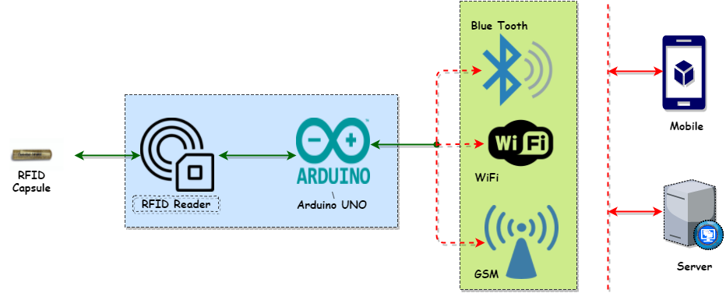

The figure above depicts a possible solution for achieving the project goals. It consists of

1. An RFID reader: The reader will be used to read the RFID capsule embedded on the animal skin
2. Arduino UNO Microprocessor: The microprocessor can be programmed to process the data (in case we need to). More importantly, it acts as interface for the device to communicate with the outside world. This means that if needed it can send and receive data along with any other additional processing. The Arduino can also act as an intermediary server.
3. The Arduino processor communicates with the world outside using one of the three options. These options have to be integrated into the final product
   1. Blue tooth: Integration of blue tooth allows for the device to be paired with a mobile device or computer. This is a very cheap option, but it allows communication over short distances
   2. Wi-Fi: Using a Wi-Fi component the device can communicate with nearby mobile devices with Wi-Fi connectivity to communicate with the external services
   3. GSM: This is the most expensive option but the most versatile option. It allows for the device to communicate directly with web services. The device will need a mobile data plan

All of the above components i.e. the Card reader, Arduino UNO microprocessor & wireless transmitter may be combined to create a single device.

Procuring these components individually will cost less than INR 2000.